|  |  |
| --- | --- |
| **Instruction Sheet** | **Learning Guide #22** |

This learning guide is developed to provide you the necessary information regarding the following content coverage and topics –

* Laying a given leather on the horse to match shades.
* Sorting and assessment of leather according to colour and grain
* Sorting and assessing leather to comply with requirements
* Separating different types of leather on cutting table and assessing for defects
* Identification and marking of defects

This guide will also assist you to attain the learning outcome stated in the cover page. Specifically, upon completion of this Learning Guide, you will be able to –

* Lay a given leather on the horse to match shades
* Sort and assess leather according to colour and grain
* Sort and assess leather to comply with the requirements
* Separate different types of leather on cutting table and assess for defects
* Identify and mark defects

Learning Instructions:

1. Read the specific objectives of this Learning Guide.
2. Follow the instructions described in number 3 to 16.
3. Read the information written in the “Information Sheets 1”. Try to understand what are being discussed. Ask you teacher for assistance if you have hard time understanding them.
4. Accomplish the “Self-check 1” in page _
5. Ask from your teacher the key to correction (key answers) or you can request your teacher to correct your work. (You are to get the key answer only after you finished answering the Self-check 1).
6. If you earned a satisfactory evaluation proceed to “Information Sheet 2”. However, if your rating is unsatisfactory, see your teacher for further instructions or go back to Learning Instruction #2. Submit your accomplished Self-check. This will form part of your training portfolio.
7. Read the information written in the “Information Sheet 2”. Try to understand what are being discussed. Ask you teacher for assistance if you have hard time understanding them.
8. Accomplish the “Self-check 2” in page __.
9. Ask from your teacher the key to correction (key answers) or you can request your teacher to correct your work. (You are to get the key answer only after you finished answering the Self-check 2).
10. Read the information written in the “Information Sheets 3 and 4”. Try to understand what are being discussed. Ask you teacher for assistance if you have hard time understanding them.
11. Accomplish the “Self-check 3” in page __.
12. Ask from your teacher the key to correction (key answers) or you can request your teacher to correct your work. (You are to get the key answer only after you finished answering the Self-check 3).
13. If you earned a satisfactory evaluation proceed to “Operation Sheet 1” in page _. However, if your rating is unsatisfactory, see your teacher for further instructions or go back to Learning Instruction #6.
14. Read the “Operation Sheet 1” and try to understand the procedures discussed

16 Do the “LAP test” in page __ (if you are ready). Request your teacher to evaluate your performance and outputs. Your teacher will give you feedback and the evaluation will be either satisfactory or unsatisfactory. If unsatisfactory, your teacher shall advice you on additional work. But if satisfactory you can proceed to Learning Guide #8.

|  |  |
| --- | --- |
| **Information Sheet-1** | **Sort and Assess Leather** |

**3.1. LAYING A GIVEN LEATHER ON THE HORSE TO MATCH SHADES**

Leathers are assorted on the horse shape table under bright lights and carefully examined for color/shade, texture, stretch, grain pattern, etc. . . . Leathers are selected which are most alike in feel, thickness.

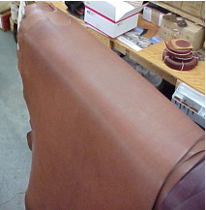

Fig. 1 : Leathers on the horse shaped table

This is done by the Human Eye and hand, it is one of the most difficult areas to train as it relies on individual skills and concepts. There are no exact standards or methods for grading leather, since is done by the grain characteristics, sight and feel developed through experience and training.

A skin is divided into five quality regions, the best part is “Butt”. This has the tightest fiber structure.

The fiber structure can vary considerably depending on the age of the animal and the living conditions. The neck and the belly have the loosest fiber structure.

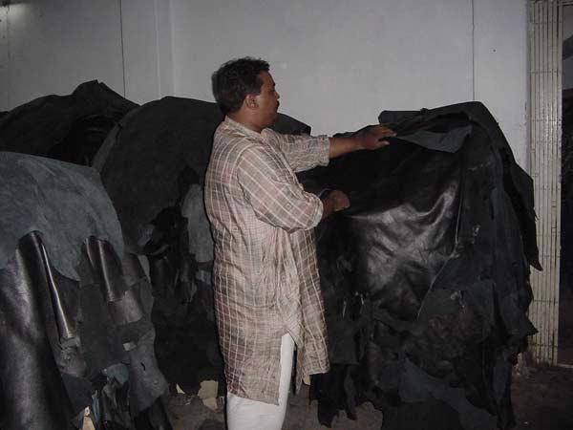

LEATHER QUALITY INSPECTION

In the cutting operation the cutting man has to select the right quality leather, because when one deals in leather he/she will find that no two skins /hides are the same, either in texture, quality or thickness. Therefore , one has to have the necessary skill to determine what parts of the hide/skin is most suitable for each component part and to be able to position cutting patterns in the correct position to minimize waste and still assuring the correct orientation of each component as to its stretch properties.

|  |  |
| --- | --- |
| Self-Check 1 | Written Test |

Name: _____________________________ Date ________________

Time started: ________________________Time finished____________

Directions: Answer all the questions listed below. Use the Answer sheet provided in the next page:

1. What is the name of the table used for leather matching?(3pts)
2. What are the important parameters to be checked during assortment of leather?(7pts)

***Note:* Satisfactory rating - 8 points Unsatisfactory - below 8 points**

You can ask you teacher for the copy of the correct answers.

Answer Sheet

Score = ___________

Rating: ____________

Name: _________________________ Date: _______________

Short Answer Questions

1. ________________________________________________________________

________________________________________________________________

________________________________________________________________

________________________________________________________________

1. ________________________________________________________________

________________________________________________________________

________________________________________________________________

________________________________________________________________

1. ________________________________________________________________

________________________________________________________________

________________________________________________________________

________________________________________________________________

________________________________________________________________

________________________________________________________________

________________________________________________________________

________________________________________________________________

_______________________________________________________________

|  |  |
| --- | --- |
| Information Sheet 2 | Sorting and assessment of leather according to color and grain |

Sorting leather before cutting will depend on the producer requirement according to the required product quality and the type of leather needed for the design of the material. Mostly the sorting of leather can be as follows –

* Sorting by Color – Which will help to group the same color shading from a bundle of leather and to have the same color shade in one model at the time of cutting for a product.
* Sorting by size or area of leather – This type of sorting will assist the proper utilization of material to use bigger sizes for bigger patterns.
* Sorting by thickness – The thickness of the material can be split the sorting of leather by thickness will assist to use the thicker material for the required part. This is mostly important for leather garment.
* Sorting by texture / grain – Leather having similar texture will be sorted for the process needed.

**Color matching**

In aniline dye batch, the leather should have to be matched for shade and the components of the article have to be cut from the matched grain of same shade.

In case of pigment finished leather the defects would have been covered due to a thick color coating. In this case, especially the backbone area is measured and any mark is visible, it is not advisable to use these portions in the front panel of the article.

**Grain matching**

Most of the time the panel of leather garments is sectioned. In this case the grain of each component should be matched; otherwise the articles will appear odd and doesn’t have good appearance.

Matching grain is an important factor, particularly for the high grade articles proper consideration of grain matching is necessary. Of course for minimization of wastage and cost reduction some items grain matching has been difficult, but in all articles the front panel of article is usually have well matched grain pattern.

|  |  |
| --- | --- |
| Self-Check 2 | Written Test |

Name: _____________________________ Date ________________

Time started: ________________________Time finished____________

*Instructions:* Answer all the questions listed below. Illustrations may be necessary to aid some explanations/answers. Write your answers in the sheet provided in the next page.

1. Write the purpose of color matching?(6pts)
2. What does grain part of leather meant? (6pts)

***Note:* Satisfactory rating - 10 points Unsatisfactory - below 10 points**

You can ask you teacher for the copy of the correct answers.

Answer Sheet

Score = ___________

Rating: ____________

Name: _________________________ Date: _______________

Short Answer Questions

1. ________________________________________________________________

________________________________________________________________

1. ________________________________________________________________

________________________________________________________________

|  |  |
| --- | --- |
| Information Sheet 3 | Sorting and assessing leather to comply with requirements |

The area of best quality of leather generally corresponds to those areas of best substance. However, other factors must be taken in to consideration when considering the quality of the leather.

* The proportion of prime material compared with the size of the skin.
* The regularity of the substance.
* The shape of the skin like, good square shape or narrow etc.
* The defect with the skin like, natural, mechanical and disease disfiguration which have occurred during the animal life.

The substance and quality of different parts of leather are determined by the anatomy of the animal –

1. Butt – Is the strongest leather as this covers the delicate organs along the back, this is also most even in quality and texture and is the first quality.
2. Shoulder – Is the lighter substance which is the second-best quality.
3. Neck – It is thick in substance and heavily lined with growth marks. This portion is the third best quality.
4. Belly – Is the poorest in quality, lot of elasticity and stretchable.
5. Shank – Is light of potion it is stretchy with wrinkles, it may or not be used based on its quality.

**Sorting of leather**

It becomes necessary to sort the leathers for the average usable area and its ratio to the whole area determines the assorted grade and thus the market price. The area of leathers is measured by either pin wheel measuring machine or electronic measuring machine. The unit of measure for finished leathers is square decimetre (dm2) or square feet (sq.ft); 1 sq.ft = 9.29 sq.dm.

General sorting of leathers based on the cutting value is as given below:

Grade A = minimum useful area 80%

Grade B = minimum useful area 65%

Grade C = minimum useful area 50%

Grade D = minimum useful area 25%

Rejects = minimum useful area <25%

Sorting of area measured leathers: in area measured leather the usable area related to whole area determines the assorted and thus the market price.

General classification of area measured leather:

1. Size I = minimum used area 80%
2. Size II = minimum used area 65%
3. Size III = minimum used area 50%
4. Size IV = minimum used area 25%
5. Size V = Rejects

Properties of garment leathers: the essential properties, which one looks for in garment leathers, are:

* Drape
* Softness
* Nap in the case of suedes
* Light weight
* Surface smoothness in the case of grain garment leathers.
* Fastness to light
* Fatness to wet and dry rubbing
* Fastness to washing
* Fastness to dry cleaning in the case of suedes
* Fastness to perspiration
* Uniform level ageing
* Dye penetration in the case of suedes
* Shower proofness in the case of suedes
* Strength properties such as stitch tear and slit tear.

|  |  |
| --- | --- |
| Self-Check 3 | Written Test |

Name: _____________________________ Date ________________

Time started: ________________________Time finished____________

*Instructions:* Perform the following tasks. Write your answers in the answer sheet provided:

1. Discuss properties of garment leathers?(10pts)
2. How grade is given based on the cutting value?(7pts)

***Note:* Satisfactory rating - 15 points Unsatisfactory - below 15 points**

You can ask you teacher for the copy of the correct answers.

Answer Sheet

Score = ___________

Rating: ____________

Name: _________________________ Date: _______________

Short Answer Questions

1. ________________________________________________________________

________________________________________________________________

________________________________________________________________

________________________________________________________________

________________________________________________________________

________________________________________________________________

________________________________________________________________

1. ________________________________________________________________

________________________________________________________________

________________________________________________________________

________________________________________________________________

________________________________________________________________

________________________________________________________________

________________________________________________________________

|  |  |
| --- | --- |
| Information Sheet 4 | Separating different types of leather and assessing for defects |

When the leathers are assessing on the table before processing for production some variable characters of leather defects are identified. Assorting is a vital process carried out by highly skilled technicians before cutting.

In selecting leather one should have to know

* What will be made
* What techniques will be used
* What are the dimensions
* What thickness is required
* Will the leather be dyed or natural
* How are parts to be joined by glue, sewing, lacing…etc.
* Is the necessary equipment available and so on
* **2.2 Characteristics of leathers**
* Each type of leather is suited to a range of uses, according to its unique characteristics choosing the right one for the job is easy, once you know what to look for. Leather is tanned and finished on the grain side to have a smooth rich surface. Leather, which is tanned and finished on the flesh side, is called suede. Various types of finished leathers, which are used for making leather products, are described below:
* **Buff hides**: are hides from buffalo it is thick, strong and durable. Buff uppers are finished in a few shades. They are used for making heavy and luggage leather goods.
* 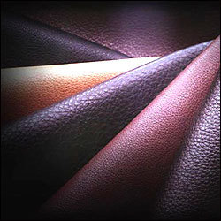
* **Cowhides**: cowhides are thick, strong and durable. They have smooth grain surface. Cowhides are finished in different colors with different techniques and are used for making a wide range of leather goods. Most commonly used finished cow hides are;
* **Cow dry-milled uppers**: are tanned with characteristic grains, developed naturally. Technique of embossing using hydraulic embossing press is also applied to get characteristic grains. They are used for making heavy, medium and small leather goods.
* 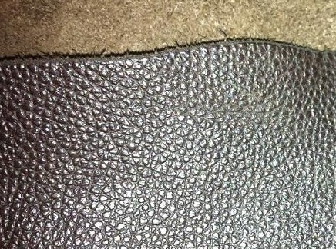
* **Cow Napa leathers**: are soft and have larger area with increased cutting value and smoothness of grain. Cow Napa leathers are used for making softy types of leather goods.
* 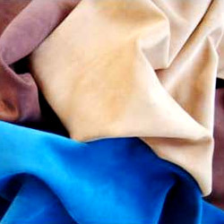
* **Upholstery leathers**: are finished in attractive colors with design printing. Upholstery leathers are largely used in furniture and automobile industries.
* 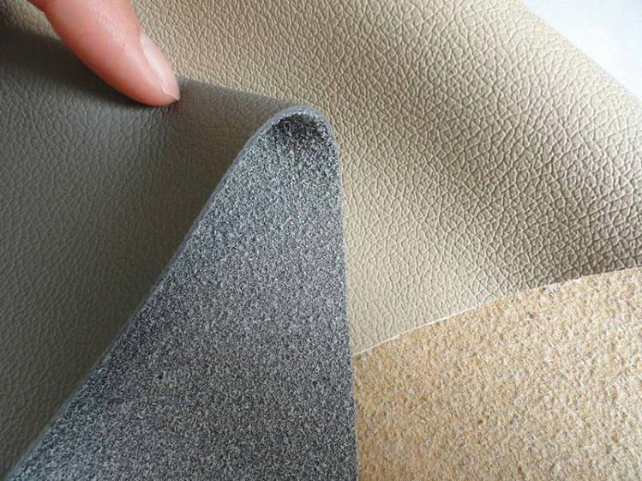
* **Split leathers**: are under layers of buff and cow hides (flesh side). Split leathers are up-graded by special finishing techniques in attractive colors. They are either plainly finished or printed.
* **Patent leather**: is a type of [japanned](http://en.wikipedia.org/wiki/Japanning) [leather](http://en.wikipedia.org/wiki/Leather) (tanned with a heavy black lacquer) that has been given a high gloss, shiny finish Characterized by a glass-like finish that catches the light, patent leather is typically solid black. Patent leather may also come in several colors such as neutral tan, white, black or even neon colors such as neon-green and hot-pink. In addition to the mirror-like finish, patent leather is also virtually waterproof, while still retaining a very flexible texture. The visual aspects of patent leather have made it a sought-after material for formal accessories.
* 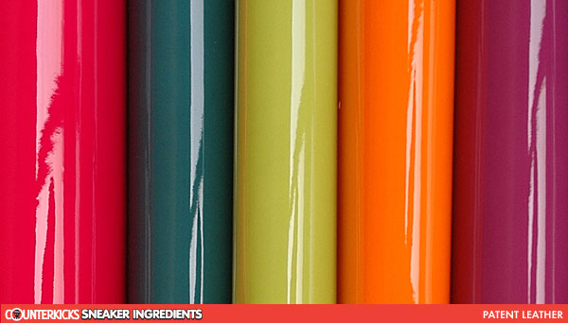
* **N.B:** a hide is the upper most natural covering of big animal having an average size of 6 ft2 and above while a skin is the upper most natural covering of small animals having an average size of 4-6ft2
* **Skins**
* **Buffalo/cow calf skins**
* Calf skin is the term generally used to describe an animal in suckling stage. Dyed calfskins are very rich in appearance and have a soft smooth satin-like finish (weave that typically has a glossy surface). These skins are used for making small and sophisticated leather goods.
* **Goat skins**
* These are strong, durable soft skins. Their fibers are short and compact. Naturally finished goat skins are used for making leather goods with carving, tooling and embossing works. Most commonly used finished goat skins are;
* **Goat uppers**: are tanned with smooth and bright glossy finish. Glaze kids are generally used for making novelty goods.
* **Morocco leathers**: are fine and lovely finished goat skins. They are thin by longwearing and come in a limited number of colors and are especially known for its rich red hue.

**Goat suede**

Goat [suede](http://www.wisegeek.com/what-is-suede.htm) is subcategory of suede leather. Goat refers to the type of animal skin used, while suede refers to a specific treatment used to achieve a soft nap on the leather. Whereas full-grain leather is made from the outer side of an animal skin, that which the fur was attached to, suede leather uses the inner side. The inner side is more supple to begin with but is further softened and made flexible by buffing its surface to create the slightly fuzzy texture of suede. Some skins may also be split, the inner side of the leather from the outer side, leaving very flexible and soft suede.

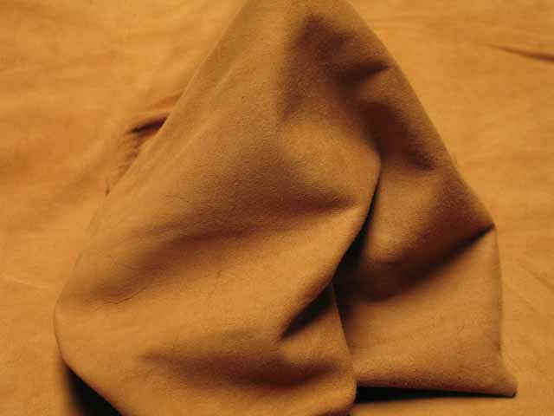

Fig. 3: Goat Suede Leather

While softer and often considered more comfortable than full-grain leathers, suede is less durable and requires more upkeep. A stiff brush, with soft bristles, should be used regularly to loosen and brush away dirt that may be attracted to the suede’s surface. Water can badly stain suede, so a waterproofing spray should be applied directly after brushing at least once a year and more frequently if the suede item is used constantly. Note that any waterproofing spray should be tested in an inconspicuous spot for discoloration.

**Nu buck**

Nu buck is top-grain cattle [leather](http://en.wikipedia.org/wiki/Leather) that has been sanded or buffed on the grain side, or outside, to give a slight nap of short protein fibers, producing a velvet-like surface. It is resistant to wear, and may be white or colored.

Nu buck is similar to [suede](http://en.wikipedia.org/wiki/Suede). It differs in that suede is created from the inner side of a hide, whereas nubuck is created from the outer side of a hide, giving it more strength and thickness along with a fine grain. It is generally more expensive than suede, and must be colored or dyed heavily to cover up the sanding and stamping process.

Some of the identifying characteristics are very soft to the touch, it will scratch very easily, and water drops will darken the leather temporarily (it will return to its original color upon drying).

The word nubuck probably comes from “new + [buck (skin)](http://en.wikipedia.org/wiki/Buckskin_%28leather%29)”

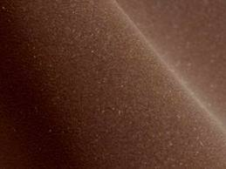

Fig. 5: Nu buck Leather

* **Sheep skins**: have a smooth grain and its strength properties are less as compared to goatskins. Sheepskins are good starting materials for making softy types of leather goods, particularly, ladies’ handbags, wallets, etc. they can be made as Napa or suede.

**Sheep Napa**

* Napa leather is made of full grain sheepskin soft, full grain gloving or clothing leather made from un-split sheep, lamb, and goat or kid skins.  It is usually tanned with alum and chromium salts and dyed throughout its substance.
* 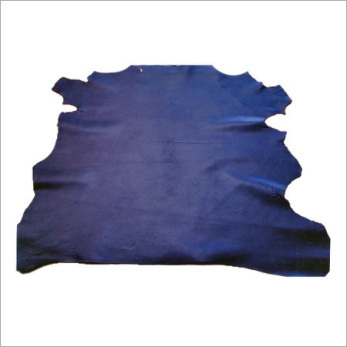
* Fig. 2: Sheep nappa leather
* **Suede leather:** is made from the underside of the skin, primarily [lamb](http://en.wikipedia.org/wiki/Domestic_sheep), although [goat](http://en.wikipedia.org/wiki/Goat), [pig](http://en.wikipedia.org/wiki/Pig), and   [calf](http://en.wikipedia.org/wiki/Calfskin)  are commonly used. Because suede does not include the tough exterior skin layer, suede is less durable but softer than standard ("full-grain") leather. Its softness, thinness, and pliability make it suitable for clothing and delicate uses; suede was originally used for women's gloves. Suede leather is also popular in [upholstery](http://en.wikipedia.org/wiki/Upholstery), [shoes](http://en.wikipedia.org/wiki/Shoe), [bags](http://en.wikipedia.org/wiki/Handbag), and other accessories, and as a [lining](http://en.wikipedia.org/wiki/Lining_(sewing)) for other leather products. Due to its textured nature and open pores, suede may become dirty and absorb liquids quickly.
* 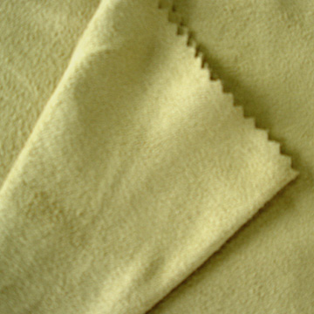
* **Exotic skins**
* Exotic skins are skis which are rare, and very costly leathers. They are skins of reptiles such as crocodiles, alligators, lizards, cobras, pythons etc.

|  |  |
| --- | --- |
| Self-Check 4 | Written Test |

Name: _____________________________ Date ________________

Time started: ________________________Time finished____________

**Directions:** Answer all the questions listed below. Use the Answer sheet provided in the next page:

1. What is the necessary information that a person should know before cutting? (5 pts.)
2. What is the difference between buff hide and cow hide? (4pts.)
3. Explain the difference between cows dry milled and cow Napa leather? (4pts.)
4. Discuss about skin and hide and mention some examples? (4 pts.)
5. What makes exotic skin different from skin/hide? (3 pts.)

***Note:* Satisfactory rating - 15 points Unsatisfactory - below 15 points**

You can ask you teacher for the copy of the correct answers.

Answer Sheet

Score = ___________

Rating: ____________

Name: _________________________ Date: _______________

Short Answer Questions

1________________________________________________________________

________________________________________________________________

________________________________________________________________

________________________________________________________________

________________________________________________________________

________________________________________________________________

_______________________________________________________________

2________________________________________________________________

________________________________________________________________

________________________________________________________________

________________________________________________________________

________________________________________________________________

________________________________________________________________

________________________________________________________________

________________________________________________________________

|  |  |
| --- | --- |
| Information Sheet 5 | Identification and marking of defects |

**DEFECTS IN HIDES AND SKINS:**

We often found a number of defects in hides and skins. These defects occur during the lifetime of the animal as well as after the death of animal.

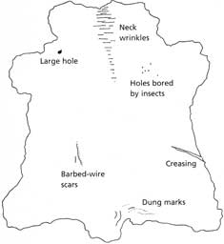

**.1.1 ANT-MORTEM DEFECTS:**

These are defects occurring during the life time of the animal we can find two categories i.e. defects/damages carried by parasite, fungal and viral diseases and defects/damages caused by mechanical means.

1. **Defects/damages occurred by parasite, fungal and viral diseases**
2. **Baldness**: is a defect seen in the regions where the bacteria are in or molds (fungi) affected the skin.
3. **Anthrax**: an infectious disease of animals that will cause a defect on the skin/hide.
4. **Tick**: a parasite which suck blood from animals. It is usually found on the inner parts of the thigh and elbow capable of making small holes in the hides by biting.
5. **Leaches**: are usually found on the surface of water. They attack the animals around the rumps and down the bellies and near the fore legs, when the animals are immersing in water pool/pond.
6. **Pox**: Viral diseases that usually appear on the skin as a red spot and turn out in to small blisters and latter grow in to a bigger size.
7. **Warble HOLES**: are fully like insects which attack the cattle and cause damages to the hides forming holes.

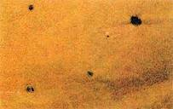

1. **Damages/defects caused by mechanical means**
2. **Brand marks**: are generally made for the identification of the animals.
3. **Yoke marks**: are the patches of hardened skin on the shoulder of the animal caused by the pressure and rubbing of the yoke against the hide during plaguing and pulling carts.
4. **Scratches**: are very common type of damages caused by thorns, bar bed wires and horns.
5. **Bruises**: found on the hip and shoulder areas due to crowding, bumping and rushing of animals sometimes caused by caning or whipping the animals.

In addition to the above defects many hides are very poor in substances because of nutrition’s and old age of the animal. A large number of cattle are allowed to linger on till they die of sheer old age. The hides of such animals are loose and lack in proper substance.

**2.1.2 POST – MORTEM DEFECTS:**

Are defects or damages occurring after the death of the animal such as:-

1. **Abrasion**: are caused to the hide or skin by dragging the animal or the carcass over the rough ground.
2. **Fly cuts**: occur due to careless flying or using improper tool for flaying.
3. **Autolysis**: when the hide or skin is removed from the animal an enzymatic degradation (self-digestion) will take place which is called autolysis. To avoid this, curing is to be done immediately after removing the hide or skin from the animal and it only slows the rate of autolysis.
4. **Hair slips**: caused by degeneration of either by autolysis or bacterial action before cutting or during storage.
5. **Grain crankiness**: in the flaying operation sometimes blunt edged hammers are used to pound the hides to remove easily from the carcass which causes the grain creakiness.

6-GOAD MARK: While ploughing the field the cattle in our country often beat by their owner with a stick which is shucked by a sharp nail on the edge. This makes permanent holes on the butt portion of the animal. This defect hampers the quality badly.

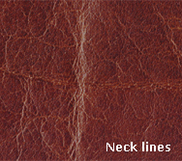

**7-Vulture mark**: when the fallen animals are left lying in the field for a long time vulture prey up on carcass puncturing the hide with sharp calves. By these punctures, the hides get damaged and reduce their value.

**8**- THORN MARKS: A long and deep scratches caused by the thorny shrubs of the fences of fields or of the jungles where the cattle stray out to graze.

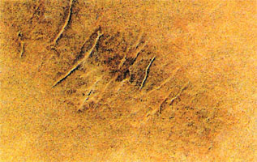

|  |  |
| --- | --- |
| **Self-Check 5** | **Written Test** |

Name: _____________________________ Date ________________

Time started: ________________________Time finished____________

**Directions:** Answer all the questions listed below. Use the Answer sheet provided in the next page:

part A

**1.Explain briefly anti -mortem defect and post- mortem defects?(8pts)**

**PART- B**

**True or False:** **(5 * 1 = 5)**

1- To make branding on animal, black hot iron is used to mark figure on the animal.

2- The cutter would normally start using the small grain skin/ coarse grain in the smallest size first.

3- Ticks get their nourishment by sucking milk from the cattle.

4- Cow Napa leathers are stiff and have larger area with increased cutting value and hard of grain.

5- Accept that each skin has a different quality standard.

***Note:* Satisfactory rating = 15 points and above Unsatisfactory rating = below 15 points** You can ask you teacher to correct your work

**PART- C (5 * 1 = 5)**

1. It generally attacks on both sides of the spinal cord. Three types of warble fly are there, name the three --

Ans.

2. Feel the leather in your---------- with it at different places. Is it same as your reference sample?

1. Head
2. Leg
3. Palm
4. Brain

3. Which Is the strongest leather as this covers the delicate organs along the back, this is also most even in quality and texture and is the first quality--

1. Butt portion
2. Belly portion
3. Neck portion
4. None

4. A small round depression on the grain side of the hide, it diorites the value of the hides.

1. Warble Fly
2. Pock Marks
3. Vulture Marks
4. Any Marks

5. Which are the Post- Mortem defects?

1. Brand marks
2. Tick marks
3. Flay cuts
4. Sore marks

***Note:* Satisfactory rating - 25 points Unsatisfactory - below 25 points**

You can ask you teacher for the copy of the correct answers.

Answer Sheet

Score = ___________

Rating: ____________

Name: _________________________ Date: _______________

Short Answer Questions

1. ________________________________________________________________

________________________________________________________________

1. ________________________________________________________________

________________________________________________________________

1. ________________________________________________________________

________________________________________________________________

1. ________________________________________________________________

________________________________________________________________

1. ________________________________________________________________

________________________________________________________________

|  |  |
| --- | --- |
| Operation Sheet 1 | **Sorting and assessment of leather according to color and grain** |

Leathers are selected which are most alike in feel, thickness, color/shade, texture, stretch, grain pattern, etc.

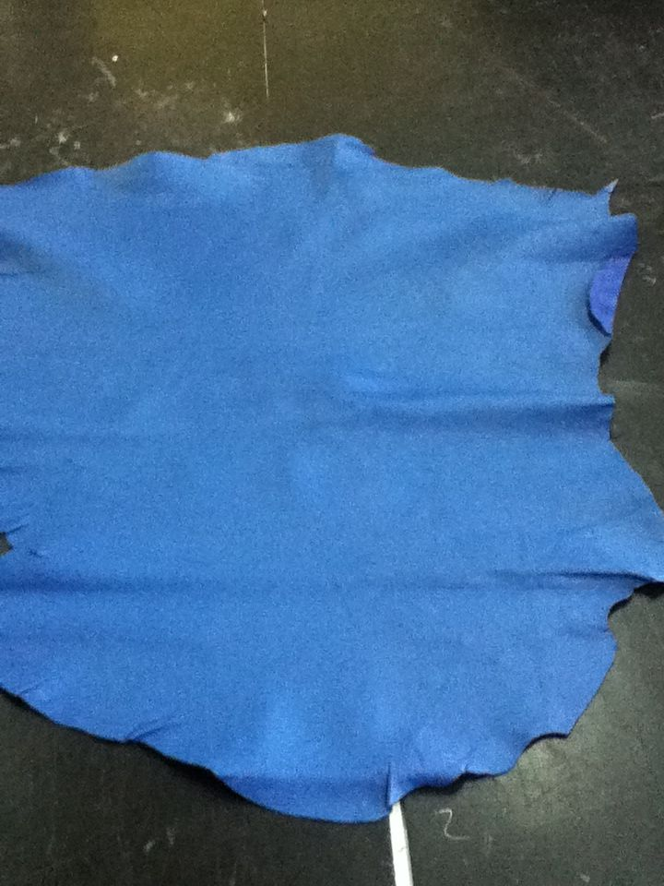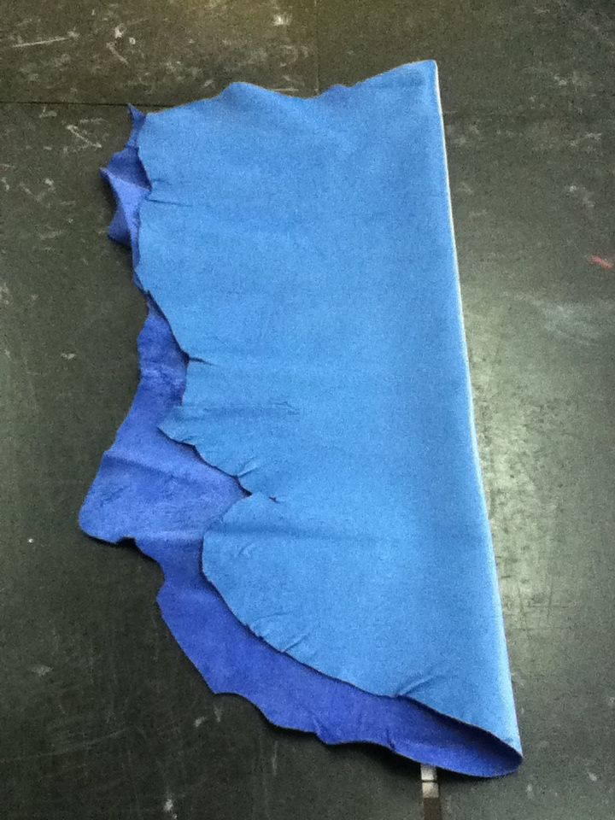

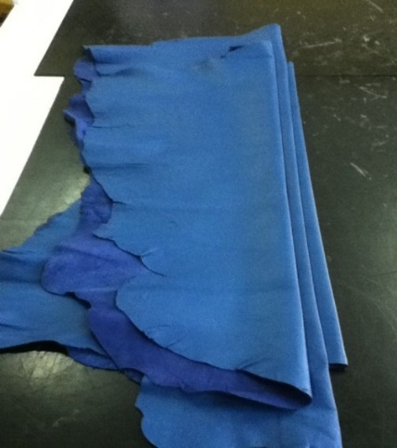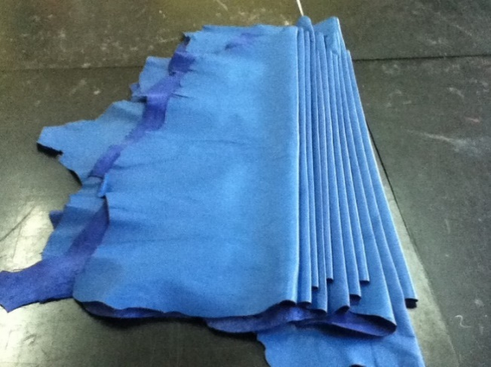

Fig. 7: Sorting and assessment of leathers

After selecting leathers, they are sent with patterns having fabricating details to the next process of cutting.

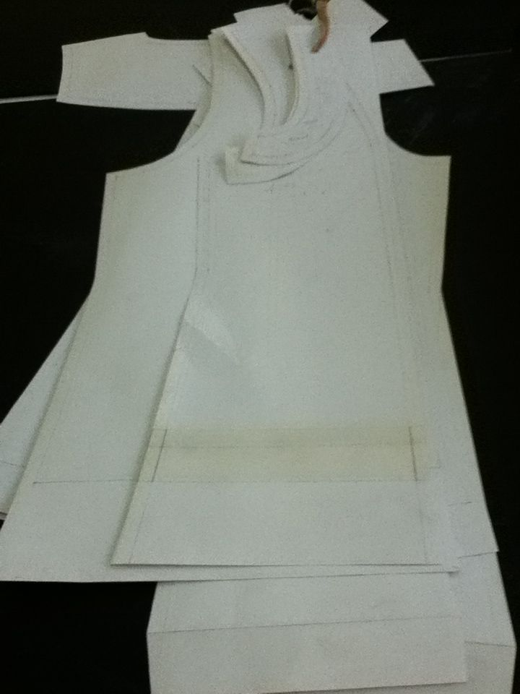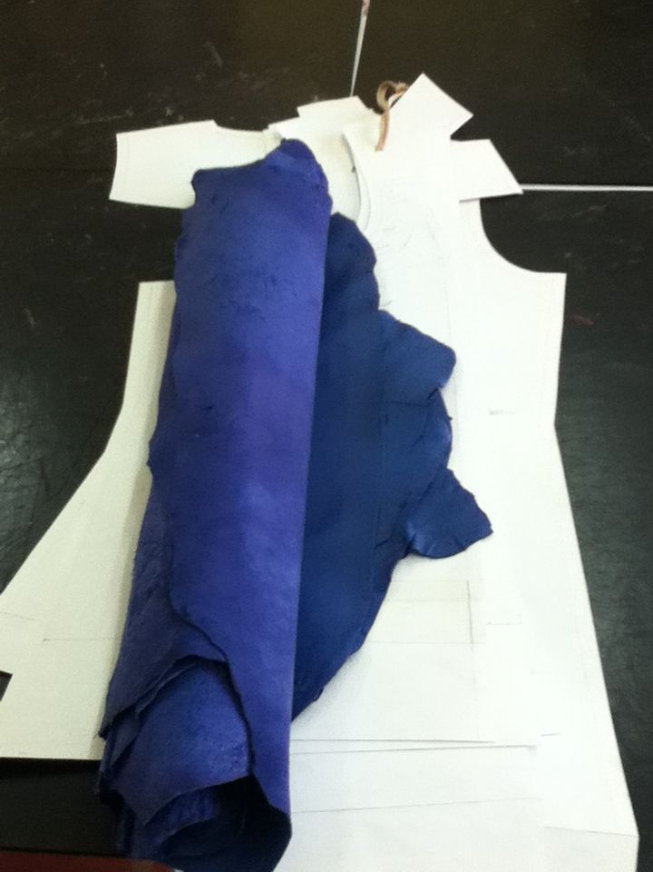

Fig. 8: Assorted leathers with patterns for cutting

|  |  |
| --- | --- |
| Operation Sheet 2 | **Separating different types of leather on cutting table** |

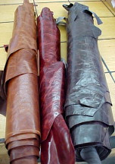

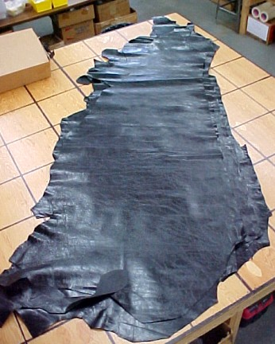

Fig. 9: Separating different types of leathers

|  |  |
| --- | --- |
| Operation Sheet 3 | **Identification and marking of defects** |

Noticeable defects are marked with a silver marking pencil, which can be easily erased by a piece of soft cloth.

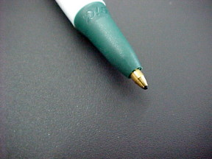

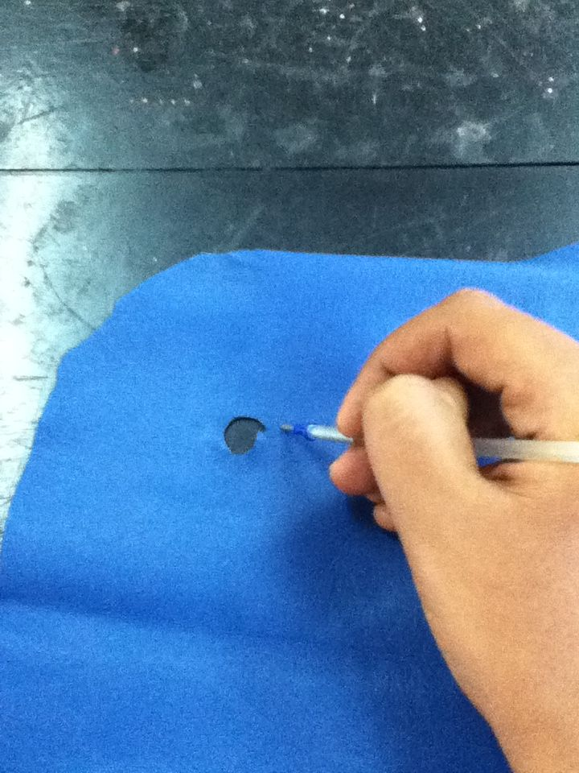

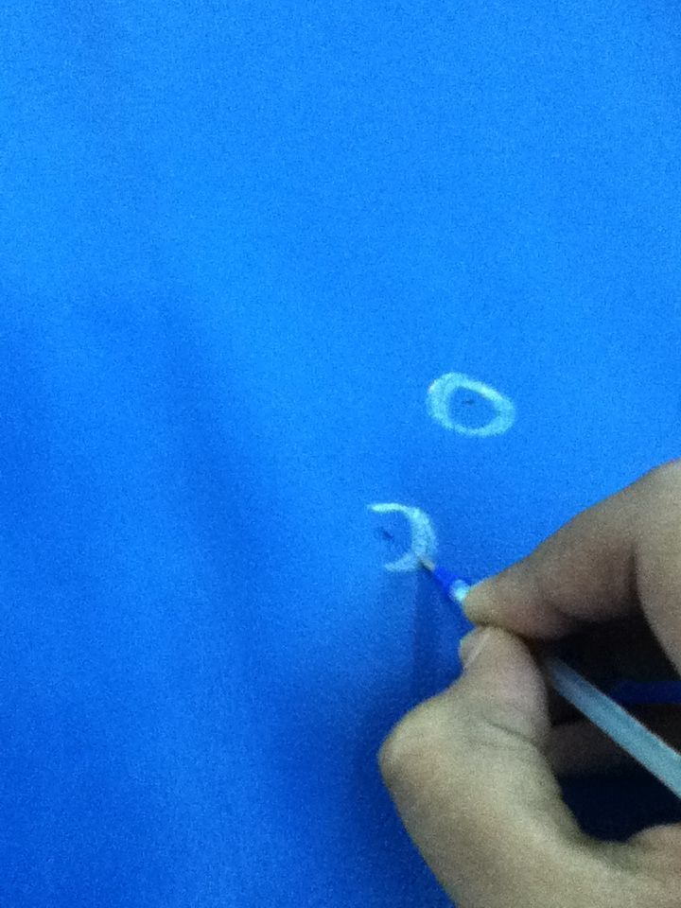

Fig. 10: Identification and marking of defects

|  |  |
| --- | --- |
| LAP Test | Practical Demonstration |

Name: _____________________________ Date: ________________

Time started: ________________________ Time finished: ________________

**Instructions**: based on the practice that you have made on how to hold your cutter/knife on the paper exercises

**Task 1**:- show how to do sorting and assessment of leather according to color and grain

**Task 2**:- identify each defect on a given leathers.

REFERNCES

https://www.buckskinl